CSE306 (Computer Architecture Sessional)

A Report On

**4-bit ALU Simulation**

Contributor Student ID:

1705068

1705069

1705070

1705071

1705074

Section: B

Subsection: B1

Group NO: **3**

Introduction:

Problem Specification:

We are to design a 4 bit-ALU Circuit as well as show the effects of various operations on flags as per the rules of Assembly Language.

Required Flags:

– Carry (C)

– Sign (S)

– Overflow (V)

– Zero (Z)

Assigned Instructions:

Inputs: A (4-bit)

B (4 bit)

cs1, cs2, cs0 (Selection bits)

|  |  |  |  |  |
| --- | --- | --- | --- | --- |
| **cs2** | **cs1** | **cs0(cin)** | **Functions** | **Form** |
| 0 | 0 | 0 | Subtract with borrow | **A +** |
| 0 | 0 | 1 | Subtract | **A + + 1** |
| 0 | 1 | x | AND | **A ∧ B** |
| 1 | 0 | 0 | Transfer A | **A** |
| 1 | 0 | 1 | Increment A | **A + 1** |
| 1 | 1 | x | OR | **A** [**∨**](https://en.wikipedia.org/wiki/Vel_(symbol)) **B** |

Truth Table

|  |  |  |  |  |  |  |  |
| --- | --- | --- | --- | --- | --- | --- | --- |
| **cs2** | **cs1** | **cs0(cin)** | **Function** | **F** | **Xi** | **Yi** | **Zi** |
| 0 | 0 | 0 | Subtract with borrow | **A +** | A | B | 0 |
| 0 | 0 | 1 | Subtract | **A + + 1** | A | B | 1 |
| 0 | 1 | x | AND | **A ∧ B** | A + B | B | 0 |
| 1 | 0 | 0 | Transfer A | **A** | A | 0 | 0 |
| 1 | 0 | 1 | Increment A | **A + 1** | A | 0 | 1 |
| 1 | 1 | x | OR | **A** [**∨**](https://en.wikipedia.org/wiki/Vel_(symbol)) **B** | A + B | 0 | 0 |

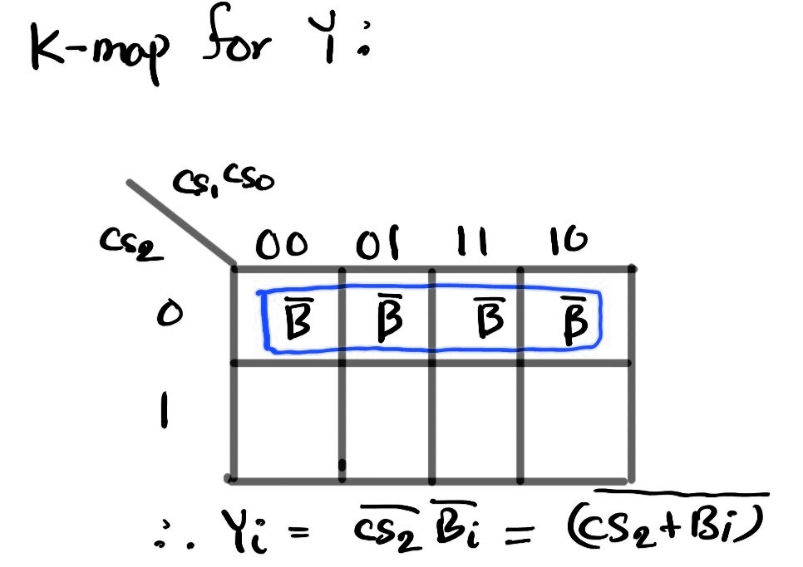



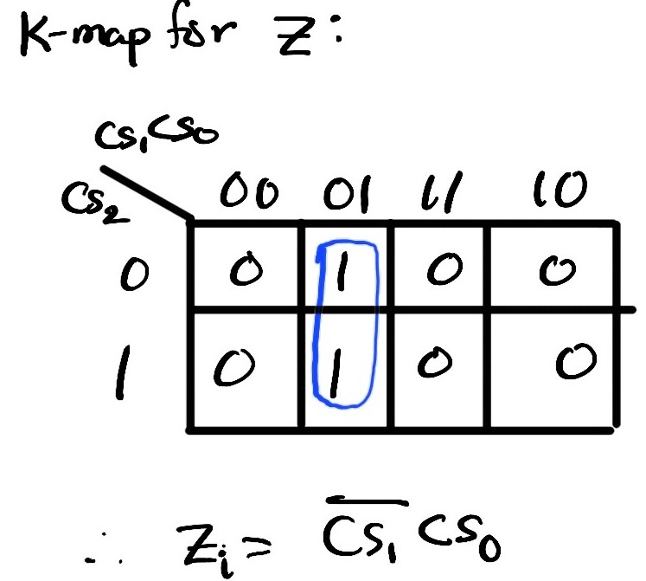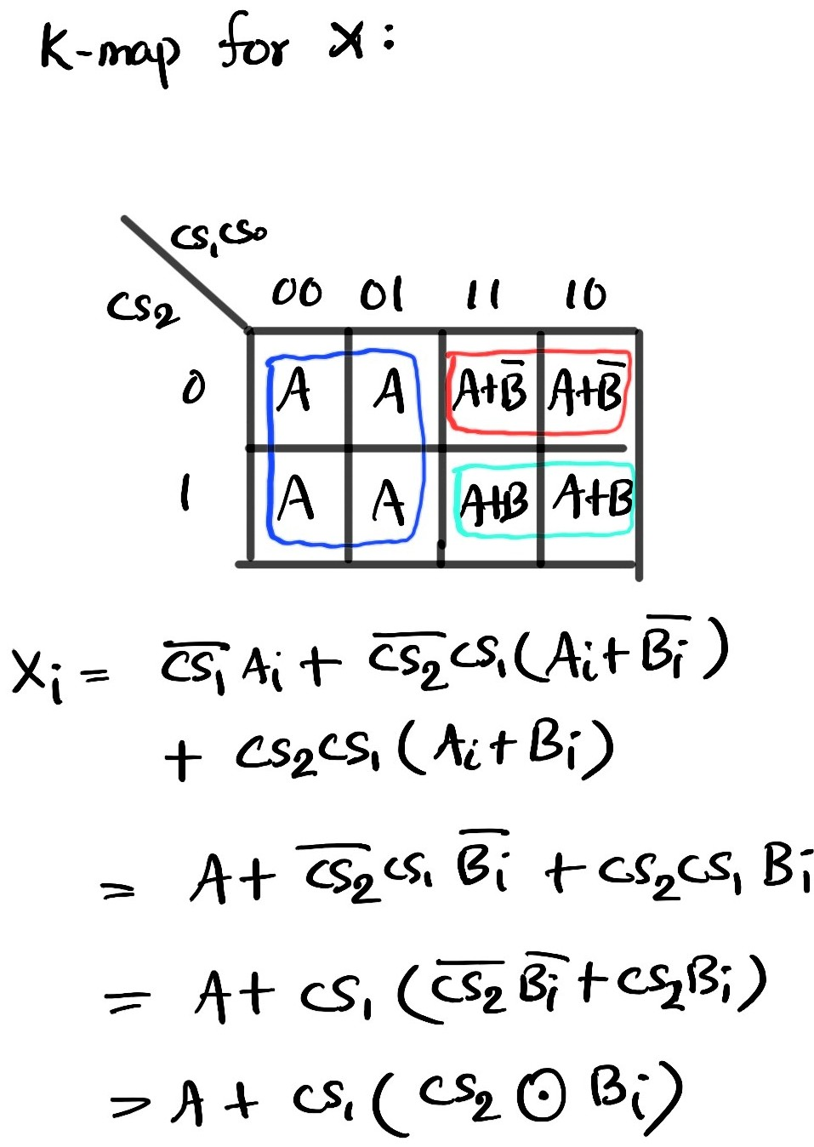



Block Diagram

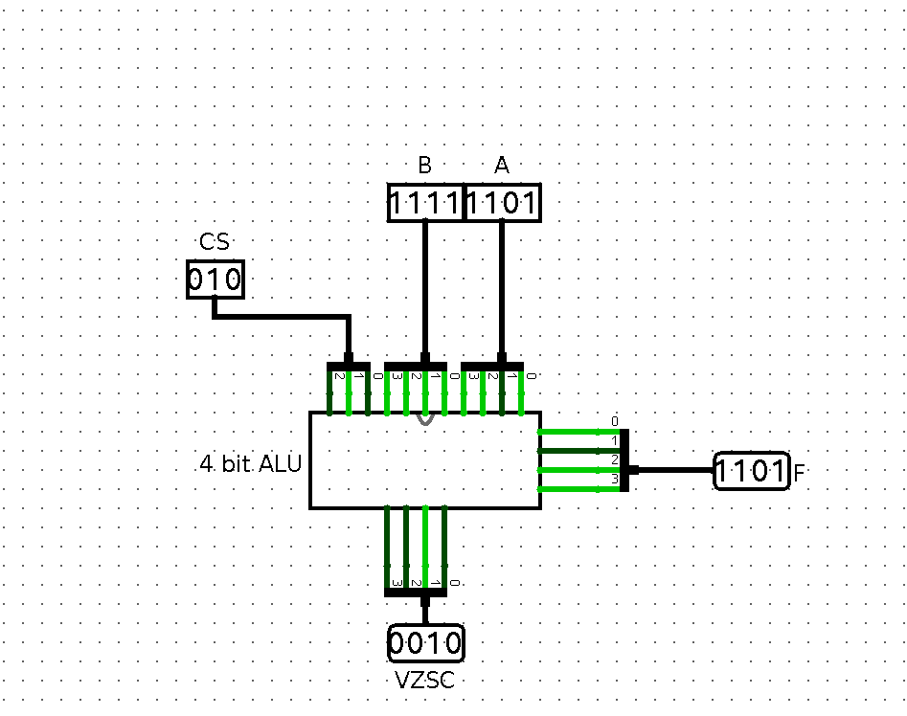

Circuit Diagram

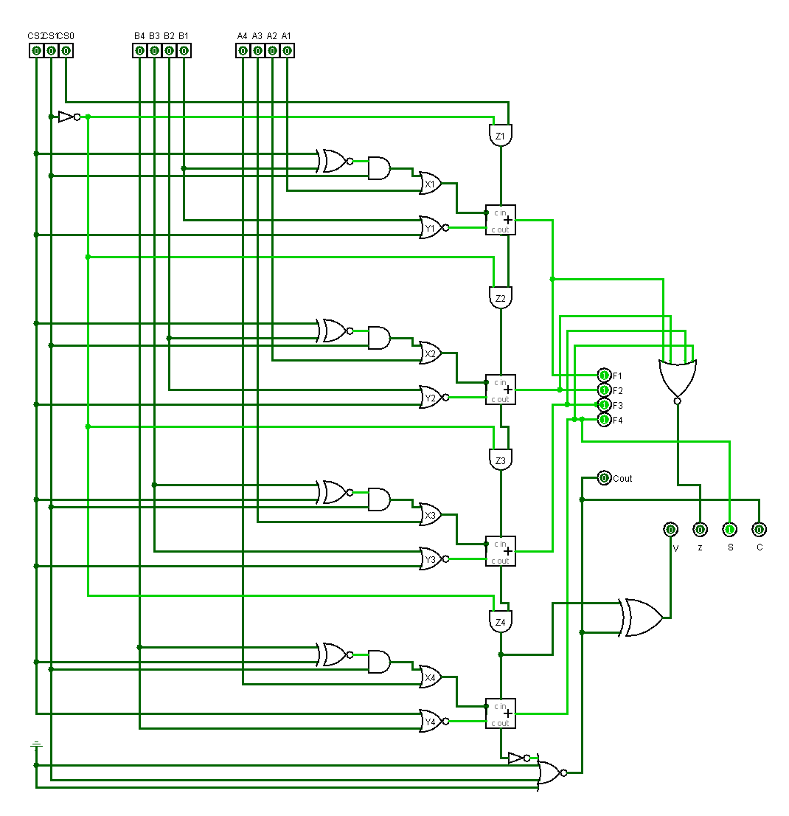IC Used with Count:

|  |  |  |
| --- | --- | --- |
| IC | IC Name | Count |
| 7402 | Quad 2-NOR Gate | 1 |
| 7404 | Hex Inverter | 1 |
| 7408 | Quad 2-AND Gate | 2 |
| 7425 | Dual 4-NOR Gate | 1 |
| 7432 | Quad 2-OR Gate | 1 |
| 7480 | 1-Bit Full Adder | 2 |
| 7486 | Quad 2-Exclusive OR Gate | 1 |
| 747266 | Exclusive-NOR Gate | 1 |
|  |  | Total = 10 |

Discussion:

In our design, first the arithmetic part was considered and a circuit was built keeping regard of the each input bit of a 1 bit full adder and input carry. Then for the already built circuit to support the logical information as well, the circuit was modified accordingly with the activation of Mode Select input cs1. This process finalized our design of ALU as per specification. y

While implementing the specified design of the ALU, a minimum number of ICs were used. We used various types of gates such as XOR, NOT, 2 input NOR, 4 input NOR, XNOR, AND, OR and 1 bit Full Adder. In order to check the status bits after the specified operations, a status register was also implemented.

During logical operations (AND, OR) implemented, as per the provided specifications, the status bits C(carry bit) and V (overflow bit) are cleared. The other two status bits S(sign bit) and Z(zero bit) provides important information about the output.